Experiment- 8
Branch: MCA (AI&ML) | Semester: 2
Student Name: Ajay Rakwal | UID: 25MCI10329
Subject Name: Technical Training | Subject Code: 25CAP-652
Section/Group: MAM-1(A) | Date of Performance: 31-03-2026

Aim of the program:
To apply the concept of Stored Procedures in database operations in order to perform tasks like insertion, updating, deletion, and retrieval of data efficiently, securely, and in a reusable manner within the database system.

Software Requirements
- Operating System: Windows / Linux
- Database Management System: MySQL / Oracle / PostgreSQL
- SQL Interface: MySQL Workbench /Web Based / pgAdmin

Objective
Apply stored procedure concepts for database operations

Procedure of the Practical
- Open PostgreSQL (pgAdmin) and connect to the required database.
- Create the Employee table with attributes such as empId, name, and salary.
- Create a stored procedure to insert employee records into the table.
- Create a stored procedure to update employee salary based on empId.
- Create a stored procedure to delete employee records from the table.
- Create a function to retrieve and display all employee records.
- Execute the procedures (insert, update, delete) and call the function to verify results.
- Observe the changes in the table after each operation.

Practical / Experiment Steps
CREATE TABLE Employee (
empId INT PRIMARY KEY,
name VARCHAR(50),
salary INT
);

--- INSERT PROCEDURE
CREATE OR REPLACE PROCEDURE insert_employee(
eid INT,
ename VARCHAR,
esalary INT )
LANGUAGE plpgsql
AS $$
BEGIN
INSERT INTO Employee VALUES (eid, ename, esalary);
END;
$$;

--- UPDATE PROCEDURE
CREATE OR REPLACE PROCEDURE update_salary(
eid INT,
new_salary INT )
LANGUAGE plpgsql
AS $$
BEGIN
UPDATE Employee
SET salary = new_salary
WHERE empId = eid;
END;
$$;

--- DELETE PROCEDURE
CREATE OR REPLACE PROCEDURE delete_employee(
eid INT )
LANGUAGE plpgsql
AS $$
BEGIN
DELETE FROM Employee
WHERE empId = eid;
END;
$$;

--- RETRIVE DATA USING FUNCTION
CREATE OR REPLACE FUNCTION get_employees()
RETURNS TABLE(empId INT, name VARCHAR, salary INT)
LANGUAGE plpgsql
AS $$
BEGIN
RETURN QUERY
SELECT * FROM Employee;
END;
$$;

--- EXECUTION PART
CALL insert_employee(1, 'Ajay', 10000);
CALL update_salary(1, 60000);
CALL insert_employee(2, 'Jatin', 50000);
SELECT * FROM get_employees();
CALL delete_employee(1);

I/O Analysis (Input / Output)
Input
- Table creation query for Employee
- Stored procedure definitions (INSERT, UPDATE, DELETE)
- Function definition for data retrieval
- Procedure calls for inserting, updating, and deleting records
- SELECT query using the function
Output
- Employee table created successfully
- Records inserted, updated, and deleted correctly using procedures
- Employee data retrieved successfully using the function
- Changes reflected accurately after each operation
- Proper execution of procedural SQL logic in PostgreSQL
OUTPUT:
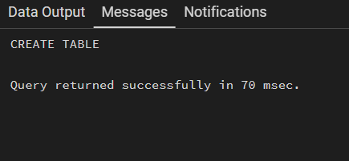
Table Created:

DELETE, UPDATE, INSERT PROCEDURE:
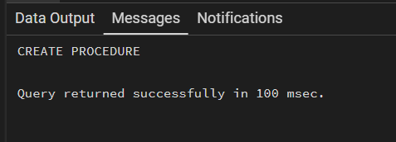

RETRIVE DATA USING FUNCTION
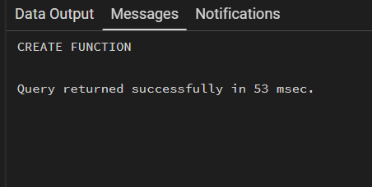

-Insert Procedure
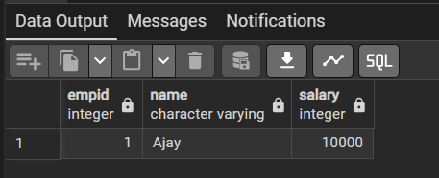

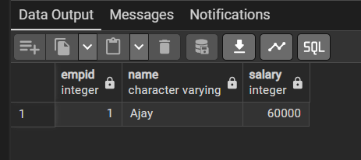
--Update Procedure

-Final before Delete Procedure
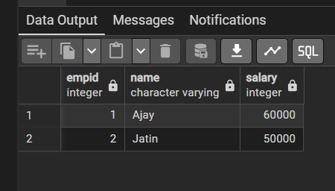

--Delete Procedure
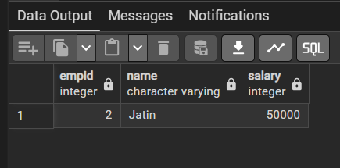

Learning Outcome:
- Understand the concept and use of stored procedures and functions in PostgreSQL.
- Learn how to perform CRUD operations (Create, Read, Update, Delete) using procedural SQL.
- Gain practical experience in writing PL/pgSQL blocks.
- Understand how functions can be used to retrieve data efficiently.
- Develop the ability to design modular and reusable database programs for real-world applications.

